**Problem 1:**

1. X-position:

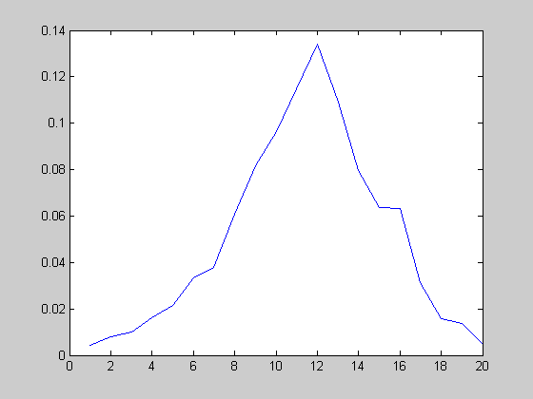

Figure 1: Plot for the prior $\{{ π}_{n}\}$

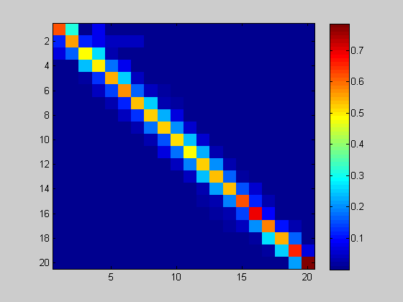

Figure 2: Plot for the transition probability {$α_{nm}$}

Plot the observation probability :

For this Cell 1, no matter where it is, the fire rate is always in a range:

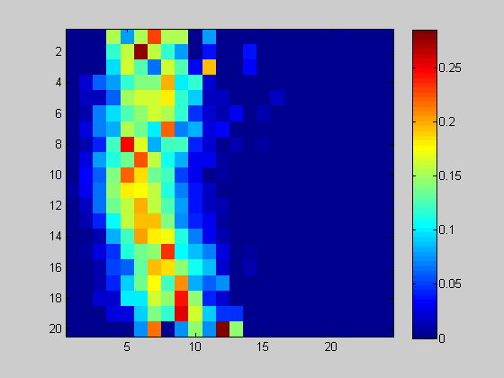

For this cell 6, the fire rate is always very concentrated.

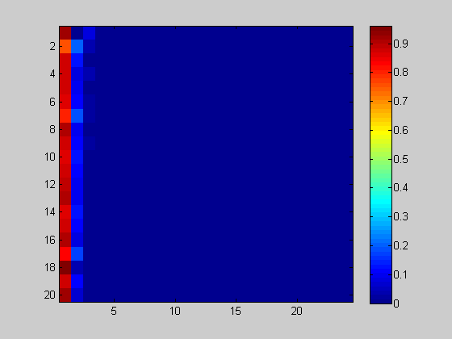

(b)

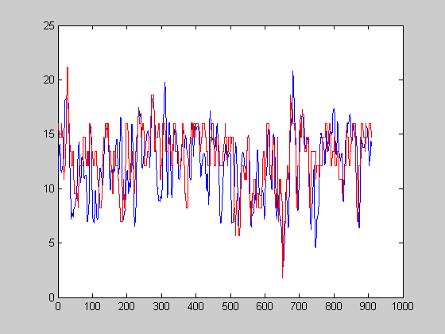

Figure 4: Plot for the estimated x-position and true x-position

R_square = 0.2186

(c) Y-position:

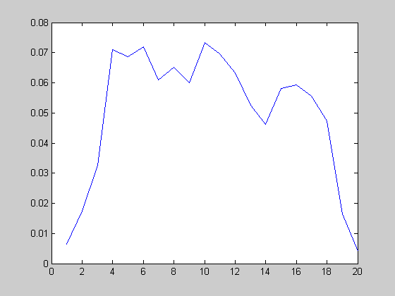

Figure 1: Plot for the prior $\{{ π}_{n}\}$

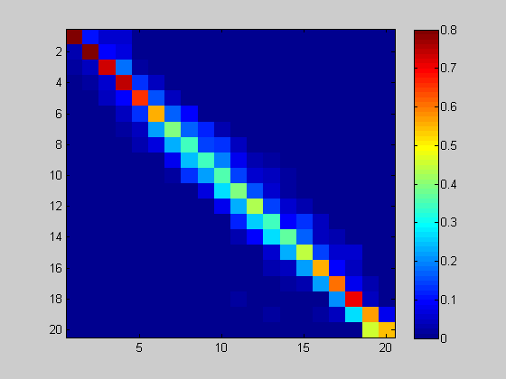

Figure 2: Plot for the transition probability {$α_{nm}$}

Plot the observation probability :

For this Cell 1, no matter where it is, the fire rate is always in a range.

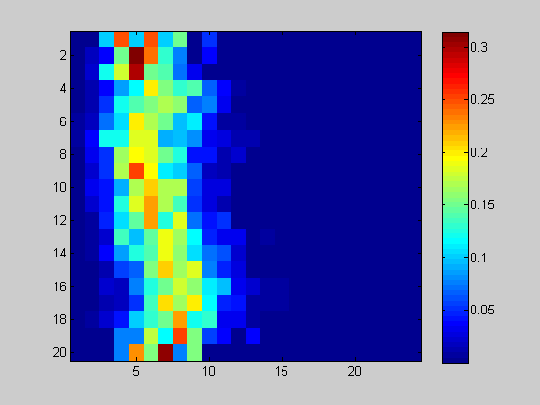

For this cell 6, the fire rate is always very concentrated.

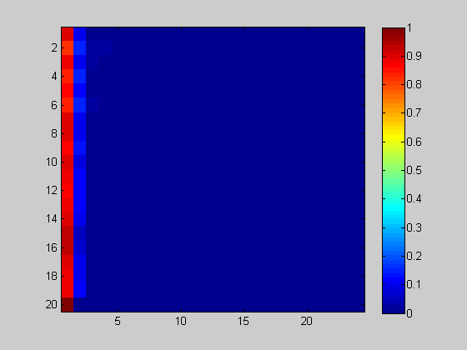

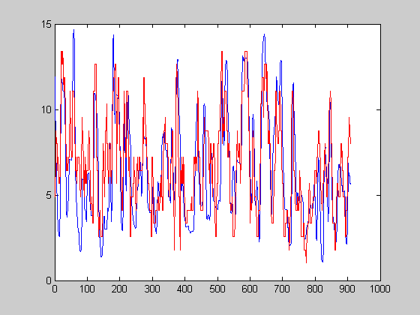

Figure 4: Plot for the estimated y-position and true y-position

R_square = 0.5228

**Code:**

%% fit the model using training data

clear;

load 'C:\Documents and Settings\goober\Desktop\hw10_1_train';

[T, C] = size(rate);

% choose either x or y position

d = 2; % 1: x-pos, 2: y-pos

kin = kin(:,d);

% discretize the kinematics

N = 20; % discretization number

max_kin = max(kin);

min_kin = min(kin);

nkin = (kin-min_kin)/(max_kin-min_kin); % scale to [0 1]

dkin = round((N-1)*nkin) + 1; % discrete state: 1, 2,..., N

% the prior of kinematics p(x_k)

for i = 1:N

Px(i) = sum(dkin == i);

end

Px = Px./sum(Px);

% the transition probability p(x_{k+1} | x_k)

for i = 1:N

for j = 1:N

Ptx(i,j) = sum(dkin(1:T-1) == i & dkin(2:T) == j);

end

end

Ptx = Ptx./(sum(Ptx,2)*ones(1,N));

R = max(rate(:))+1; % firing rate is in {0, 1, 2, ..., R-1}

% the prior of firing rate p(z_k)

for j = 1:R

Pz(j,:) = sum(rate == j-1);

end

Pz = Pz./(ones(R,1)*sum(Pz));

% the observation probability p(z_k | x_k) for each neuron

for k = 1:C

for i = 1:N

for j = 1:R

Pzx(i,j,k) = sum(dkin == i & rate(:,k) == j-1);

end

end

Pzx(:,:,k) = Pzx(:,:,k)./(sum(Pzx(:,:,k),2)*ones(1,R)+eps);

end

figure(1);

plot(Px);

figure(2);

Imagesc(Ptx);

colorbar;

figure (3);

Imagesc(Pzx(:,:,6));

colorbar;

%save hmm_1d Px Ptx Pz Pzx max_kin min_kin d N;

% decode the hmm in the test data

% use log of probability in the calculation

load 'C:\Documents and Settings\goober\Desktop\hw10_1_test';

kin = kin(:,d);

[T, C] = size(rate);

% joint probability of firing rates of all neurons conditioned on kineamtics

% assuming independence over neurons

lpz_jx = zeros(T,N);

for i = 1:T

for k = 1:C

lpzx(:,k) = log(Pzx(:,rate(i,k)+1,k)+eps);

end

lpz_jx(i,:) = sum(lpzx,2)';

end

%%% Dynamic programming to find the optimal kinematics %%%

joint_prob = zeros(T,N); % delta_t(n) in the notes

joint_prob(1,:) = log(Px+eps)+lpz_jx(1,:); % delta_1(n)

for k = 2:T

for m = 1:N

temp = joint_prob(k-1,:)+log(Ptx(:,m)'+eps)+lpz_jx(k,m);

[joint_prob(k,m), ind(k,m)] = max(temp); % ind save optimal pre-index

end

end

[ignore, x_h(T)] = max(joint_prob(T,:)); % identify last time step

for k = T-1:-1:1 % recursively identification

x_h(k) = ind(k+1,x_h(k+1));

end

kin_h = (max_kin-min_kin)*(x_h'-1)/(N-1)+min_kin; % return to the original scale

figure(4);

plot(1:T, kin, 1:T, kin_h, 'r','LineWidth',1.2);

R2 = 1 - sum((kin-kin_h).^2)/(sum((kin-mean(kin)).^2));